**Fire Safety Inspection Management System**



Davao Del Norte State College

New Visayas, Panabo City

A proposed project title submitted by:

Micho Basilio

Joylan Panungcat

Jay Art Sabandal

Regie Vasquez

Miguel Luis Ortega

March 2021

**INTRODUCTION**

**BACKGROUND OF THE PROJECT**

The Fire Department is one of the reputable establishment in Panabo City, as it serves its people not only when there are disasters in regards to fire, but also introducing legal process of inspection for Fire Safety papers compliance like reviewing the old, new, and would be establishments inside the city to see if they pass the inspection.

The Fire Department in the area of Fire Safety, currently relies on Microsoft Excel in encoding the whole information for the application of the renewal of establishment. Additionally from the inspector’s side of their process, they tend to also have their problems with their listed inspection recorded along with the financial prerequisites like inspection fees, fines, etc. that is crucial for the affirmation of the fire safety inspection certificate that is currently on a paper-based approach. Also, the said establishment addressed that there are emergency calls in which the Fire Department should respond. At their request, they would like to have an emergency distress alert from the establishments, and another rising problem from the said proposal would be the legitimacy of the distress alert if it’s the legitimate one or a prank call.

The group has decided to research what seems to be in dire improvement inside the Bureau of Fire Protection in Panabo City’s Fire Department and proposed their concept; Fire Safety Inspection Management System. This is a proposed concept done by one of the BSIT 3 Set A Capstone group, with the mentioned problems above by the Fire Department, the function includes saving certain information inside the Fire Department that focuses on establishment, inspections, fees and processes that are required by the Bureau of Fire in Panabo City with the approval of legality in Fire Safety. Along with their Fire safety inspectors, their current issue would like to be solved by proposing a digitized version of the inspection process in order to reduce the paper-based clutter. Lastly, with the issue of the running problems of receiving fake alerts from the establishment of sending distress alert to the Fire Department, the research team has their proposed functions to effectively reduce the prank calls and give rise to the order of determining the legitimacy of the distress alert coming from the unfortunate establishments.

The fact that our ever-growing world has become fast-paced, so too the establishments around should keep up in staying relevant. This project will result in development from the process of encoding in Microsoft Excel of Fire Department Fire Safety document duties, along with the Fire Safety Inspectors and the Establishment applicants’ manual data process to be improved. The Capstone Team shall create a system that will suit to the client’s needs and the Fire Safety Inspection Management System can position itself as the premier provider for the Fire Department as an effective application that will have its convenience still be relevant to withstand through time.

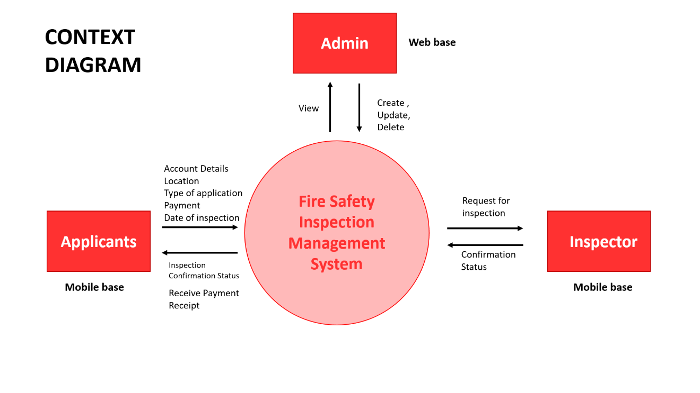

**TYPES OF APPLICATION**

* Fire Safety Evaluation Clearance (FSEC)
* Fire Safety Inspection Certificate for Occupancy
  + Educational occupancies
  + Health care occupancies
  + Industrial occupancies
  + Storage occupancies
* Fire Safety Inspection Certificate for New Business
* Fire Safety Inspection Certificate for Business Renewal

**SAMPLE PROCESSES**

**Fire Safety Evaluation Clearance (FSEC)** A document issued by the BFP as a prerequisite for the grant of Building Permit by the Office of Building Official having jurisdiction upon determination that the evaluated plans are compliant with RA 9514 and its RIRR.

Process:

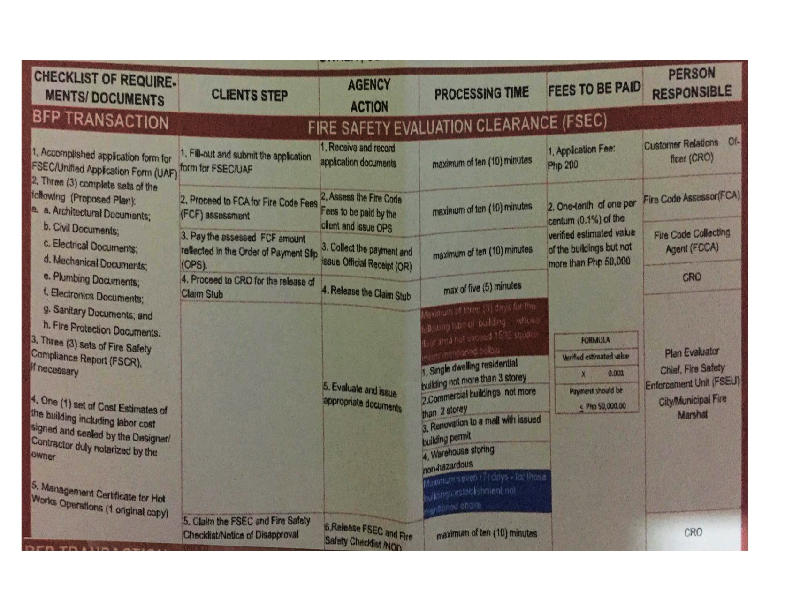

FORM

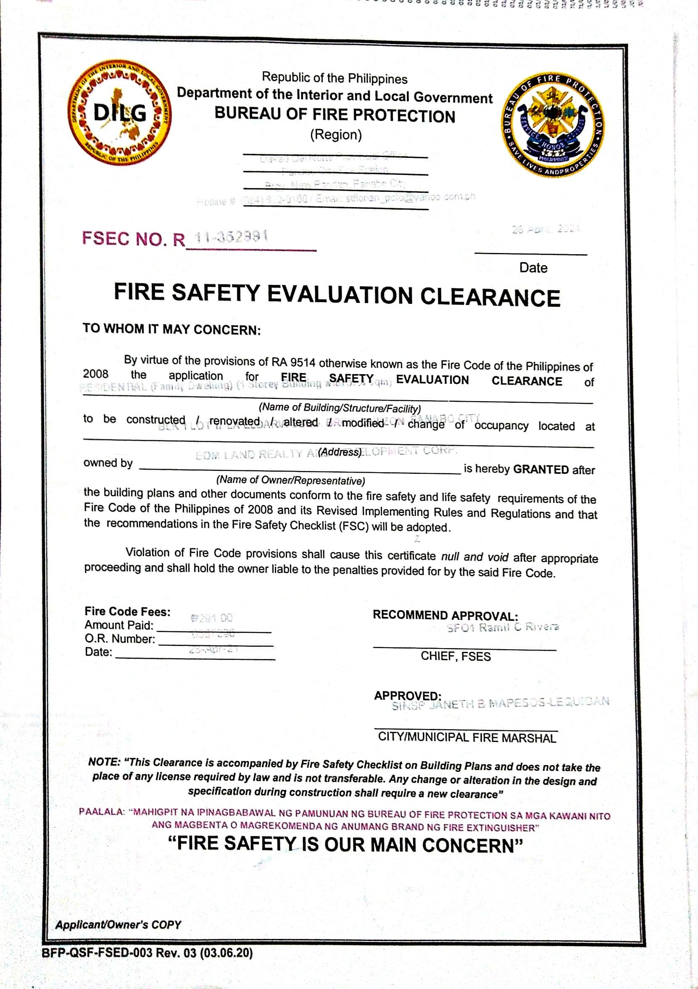

**Fire Safety Inspection Certificate (FSIC**). A document issued by the BFP as a prerequisite for the grant of Certificate of Occupancy, Business Permit, Certificate of Annual Inspection from PEZA and other licenses and permits being issued by other government agencies upon determining that the required fire safety construction are in place, and fire protective and/ or warning systems are properly installed in accordance with the approved plans and specifications and in compliance with RA 9514 and its RIRR.

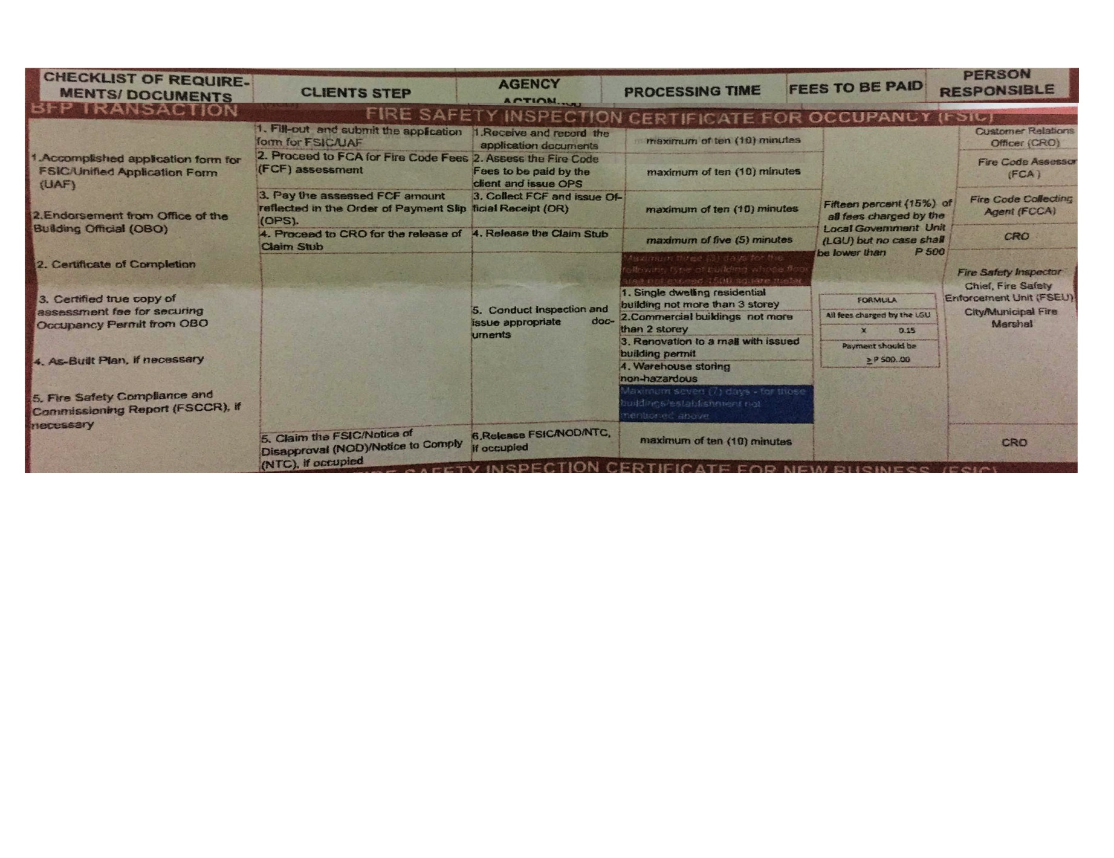**FSIC for Occupancy**

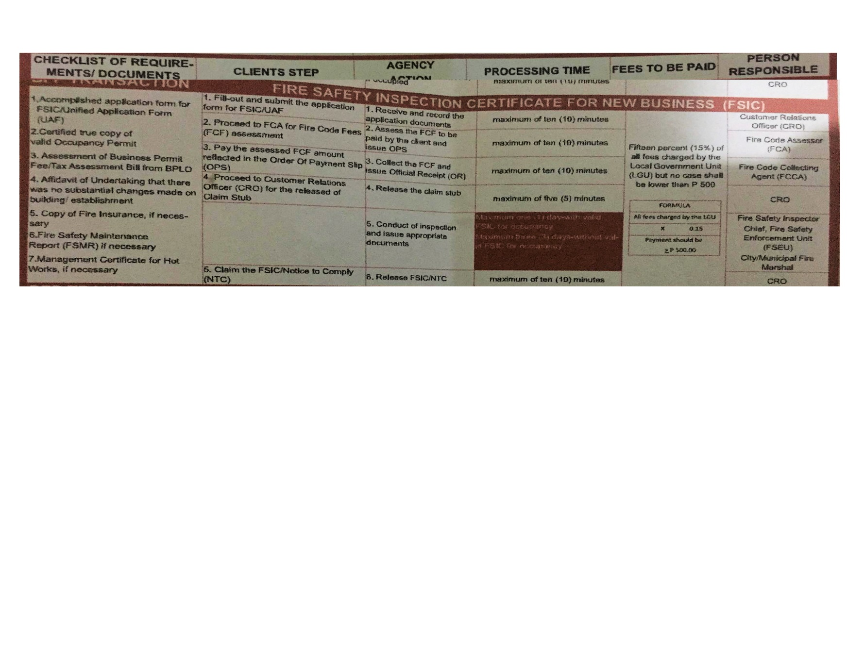 **FSIC for new Business**

**FSIC for Business Renewal**

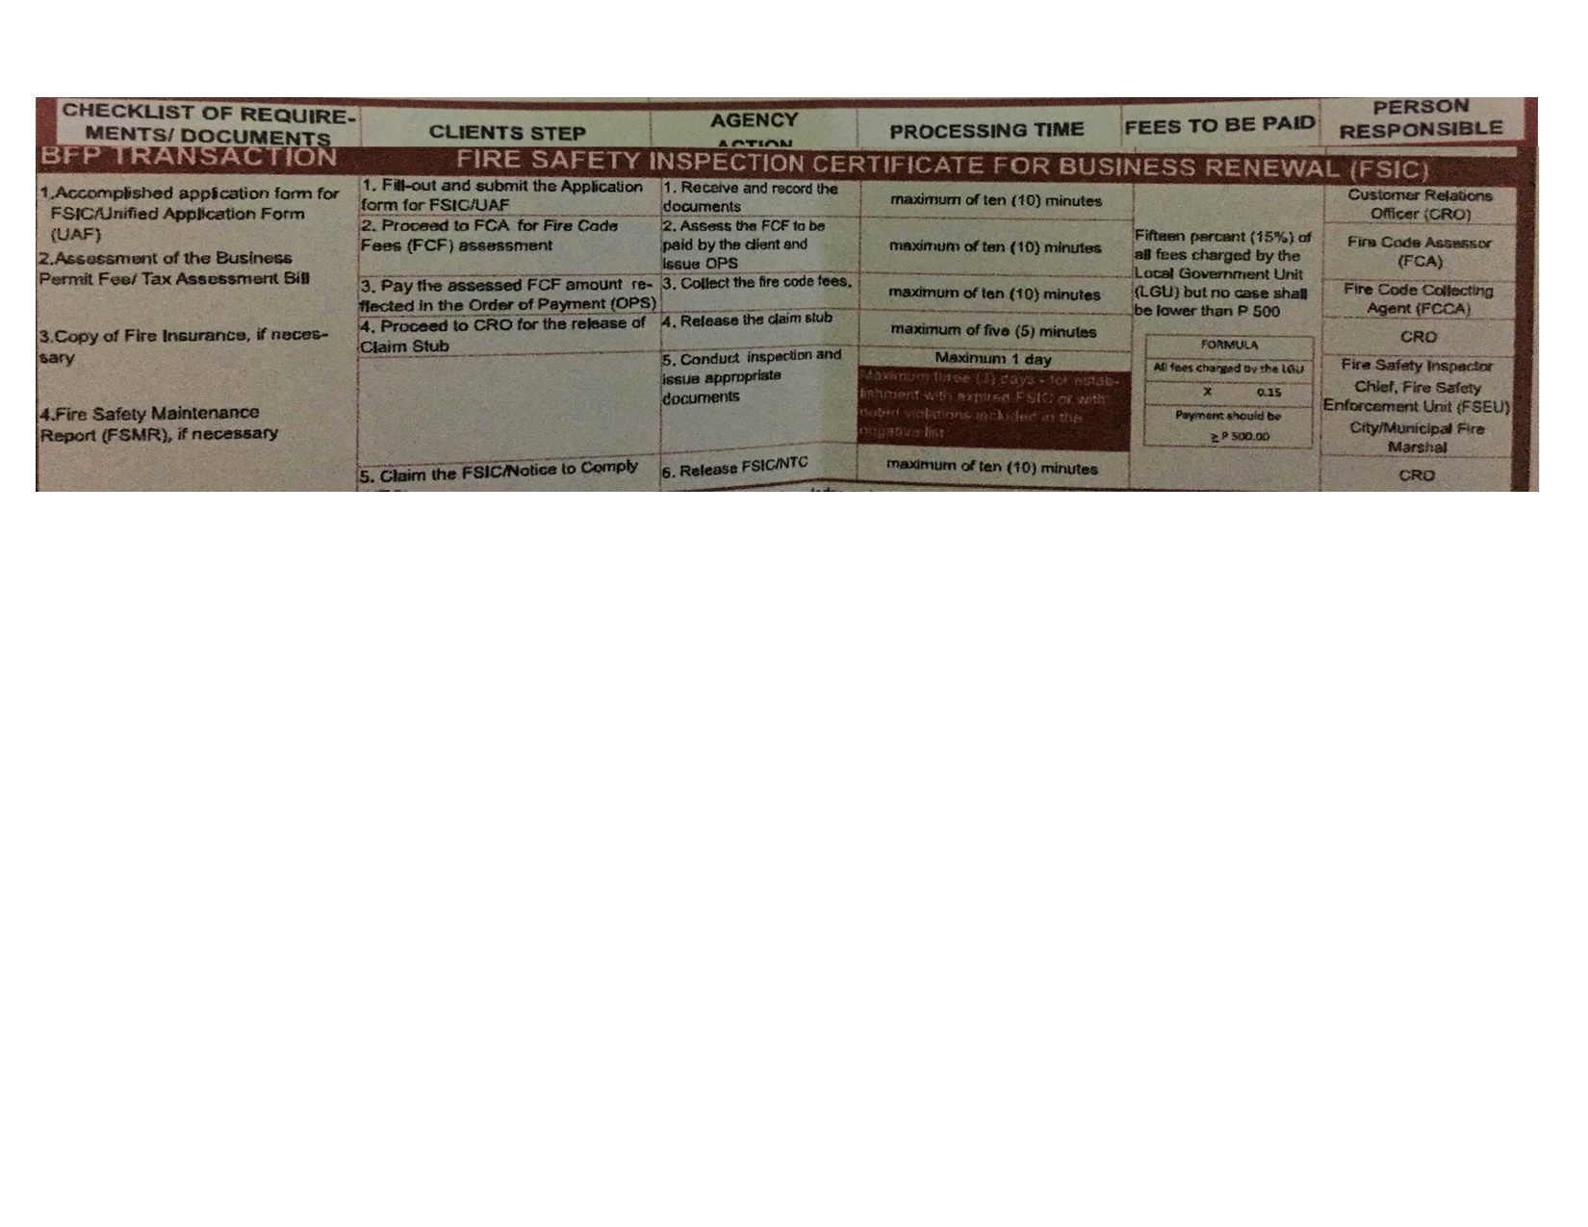

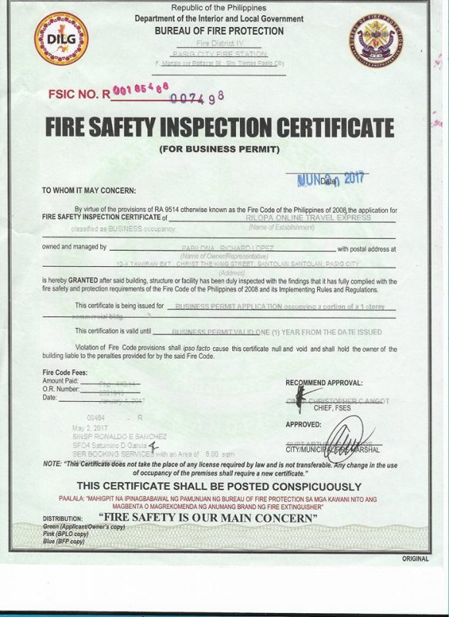 **Form**

**INSPECTOR FLOW CHART**

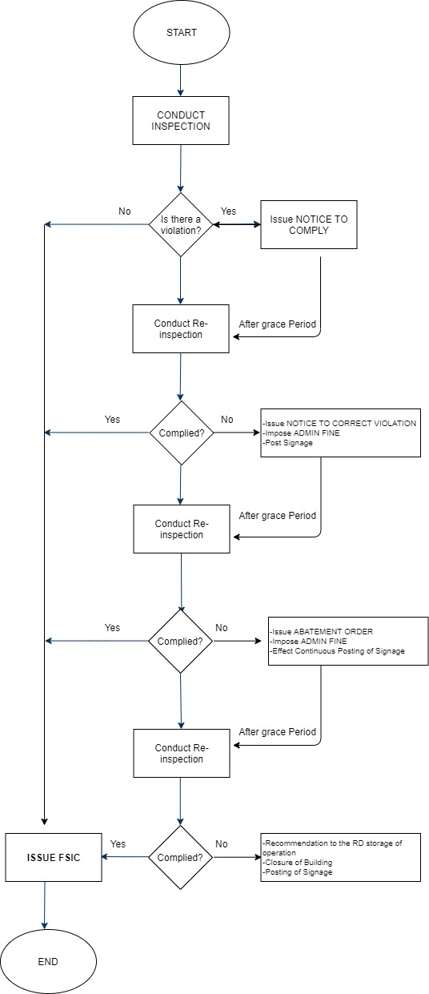

**NOTICE TO COMPLY**

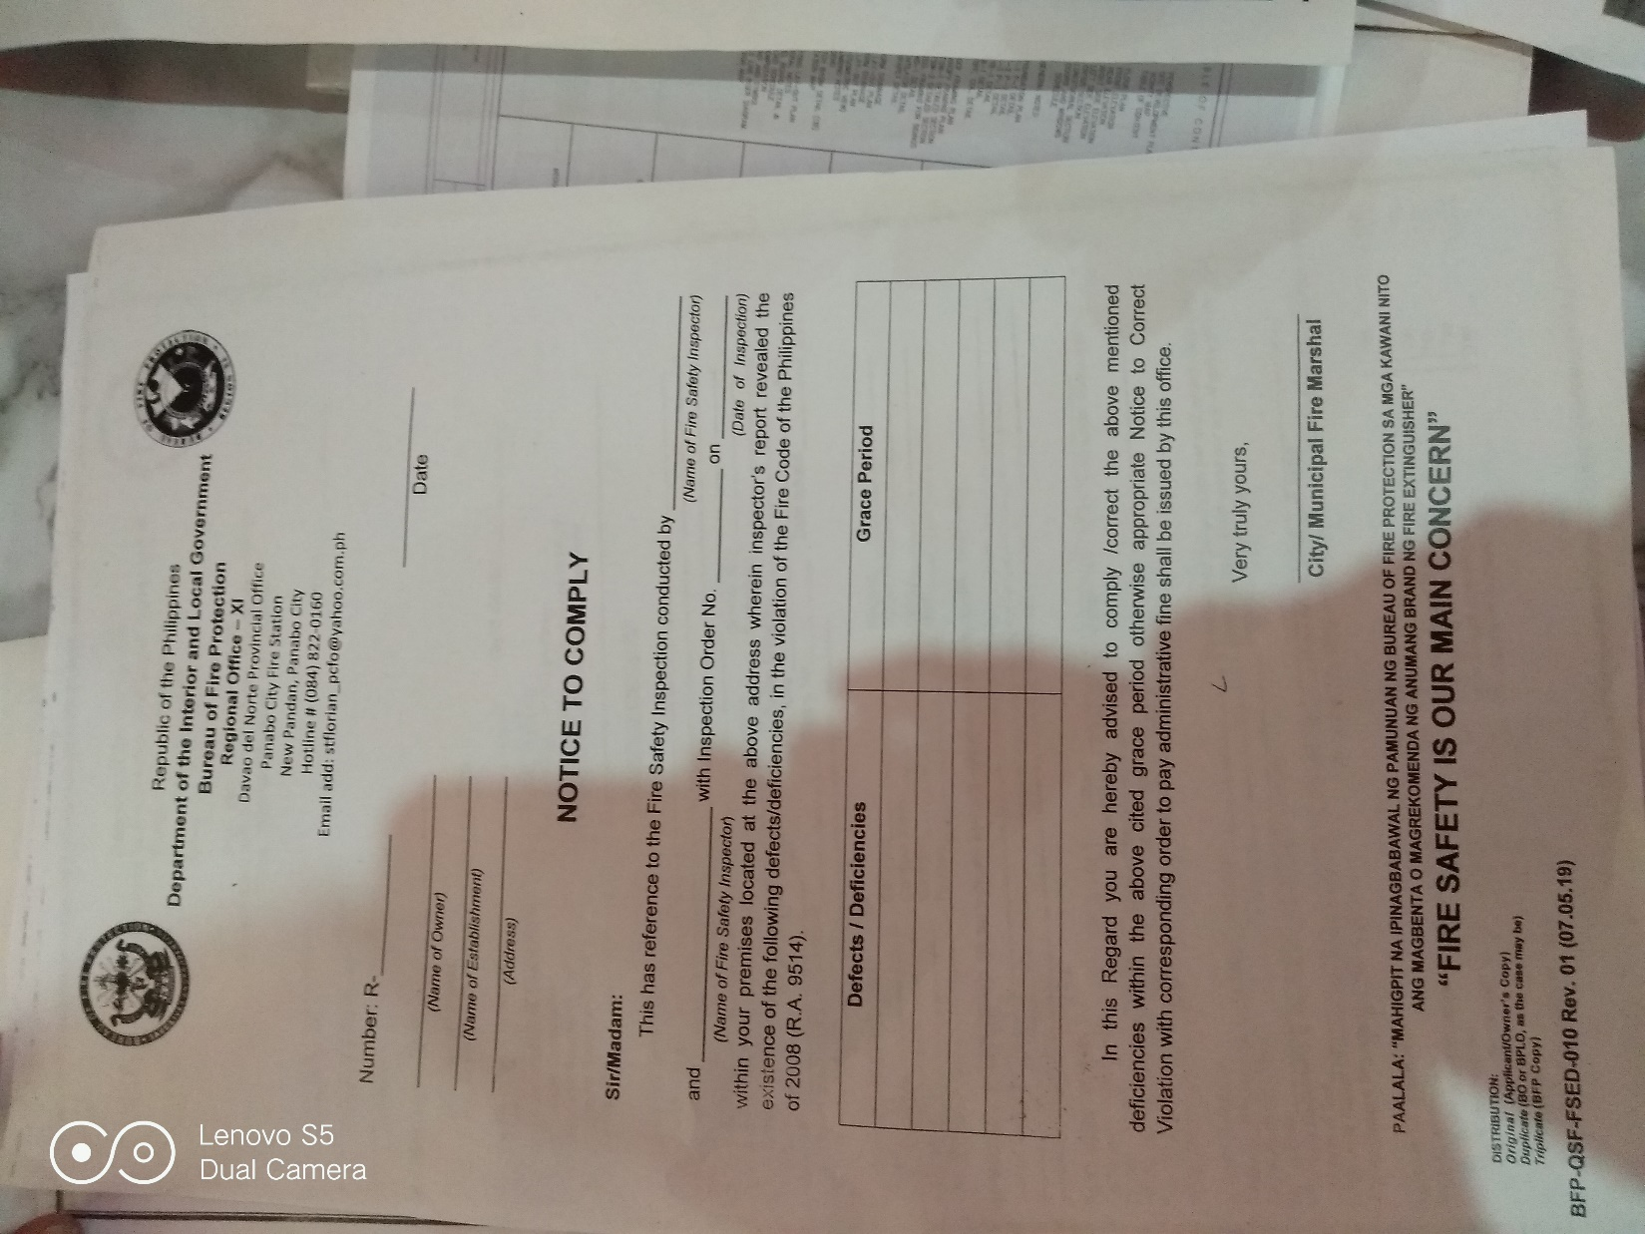

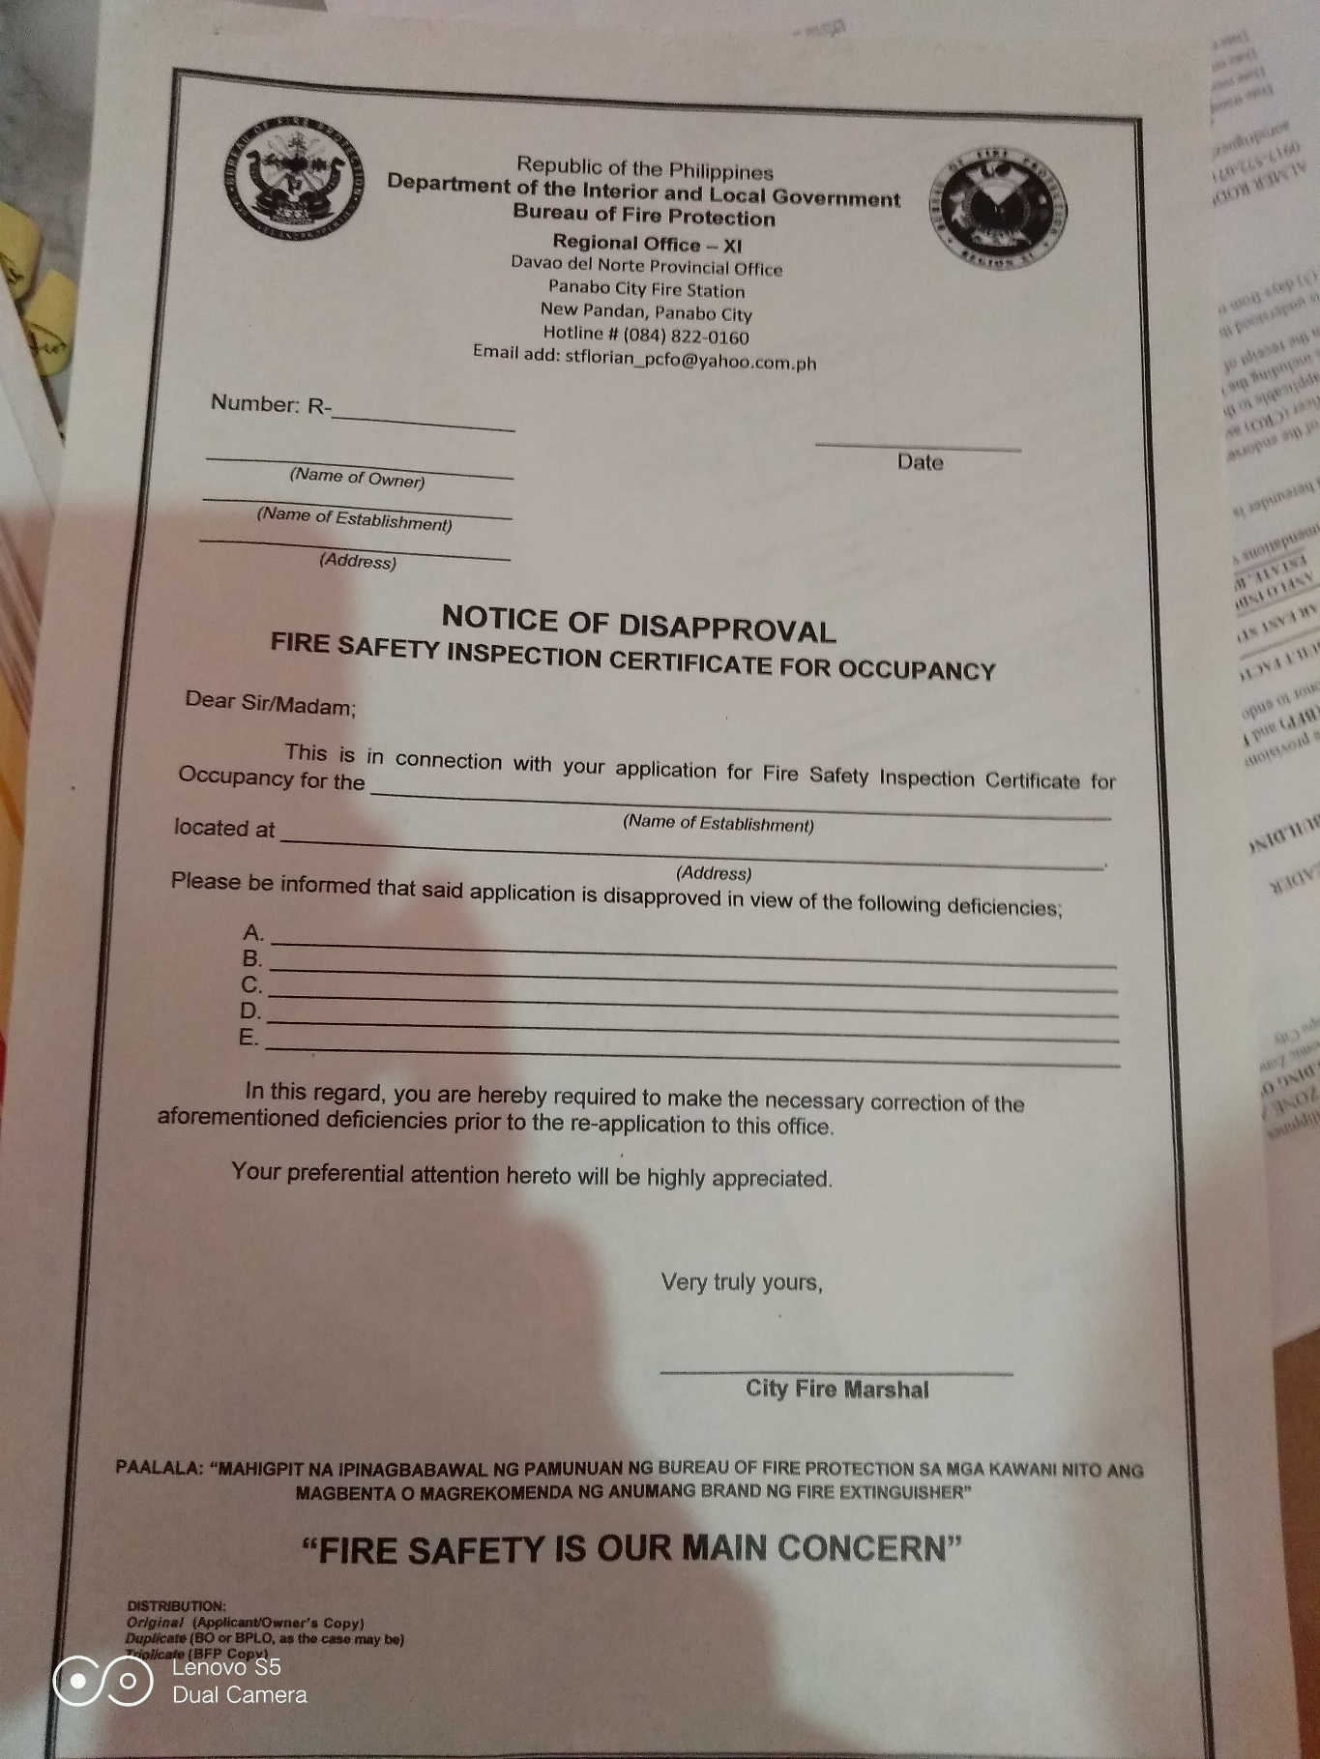**NOTICE OF DISAPPROVAL**

**INSPECTOR EVALUATION FORM/GUIDE**

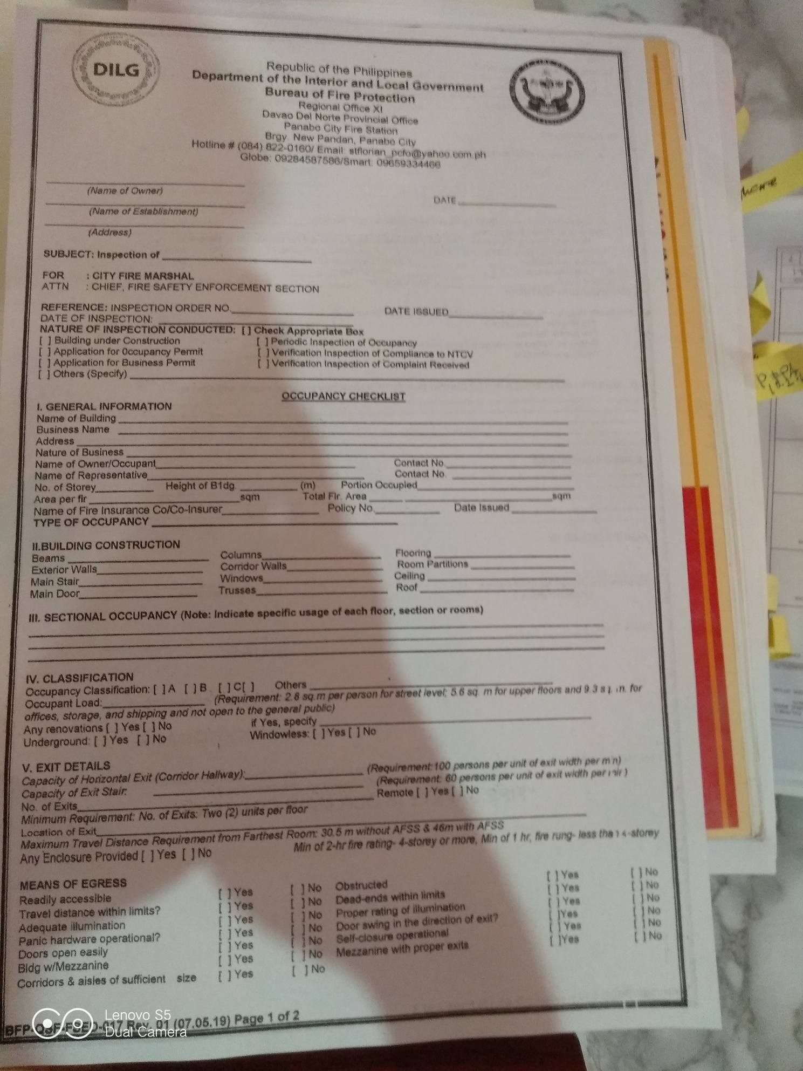

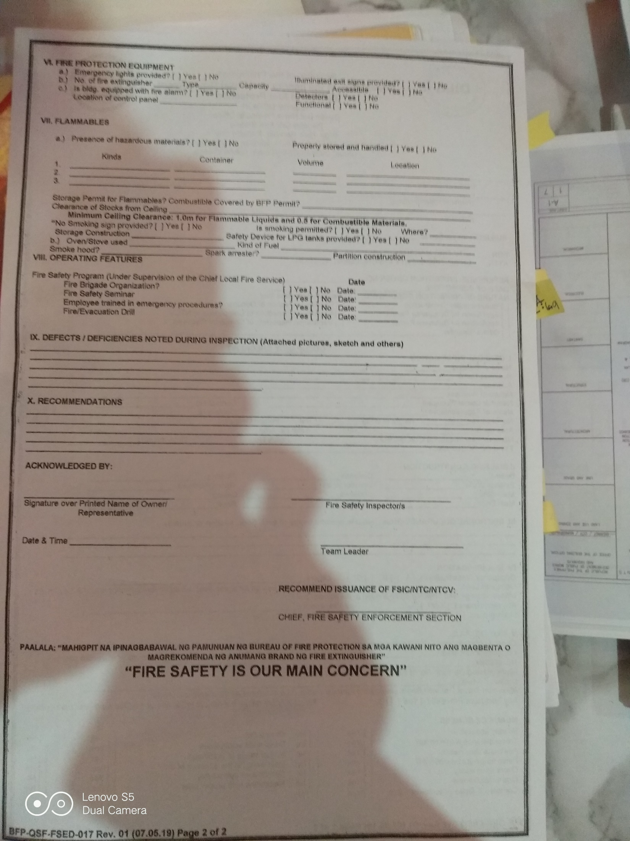

**SAMPLE DATA**

[**https://drive.google.com/file/d/1DZknz6FBIDTcRpeFFEKsukMQlkq097cI/view?usp=sharing**](https://drive.google.com/file/d/1DZknz6FBIDTcRpeFFEKsukMQlkq097cI/view?usp=sharing)

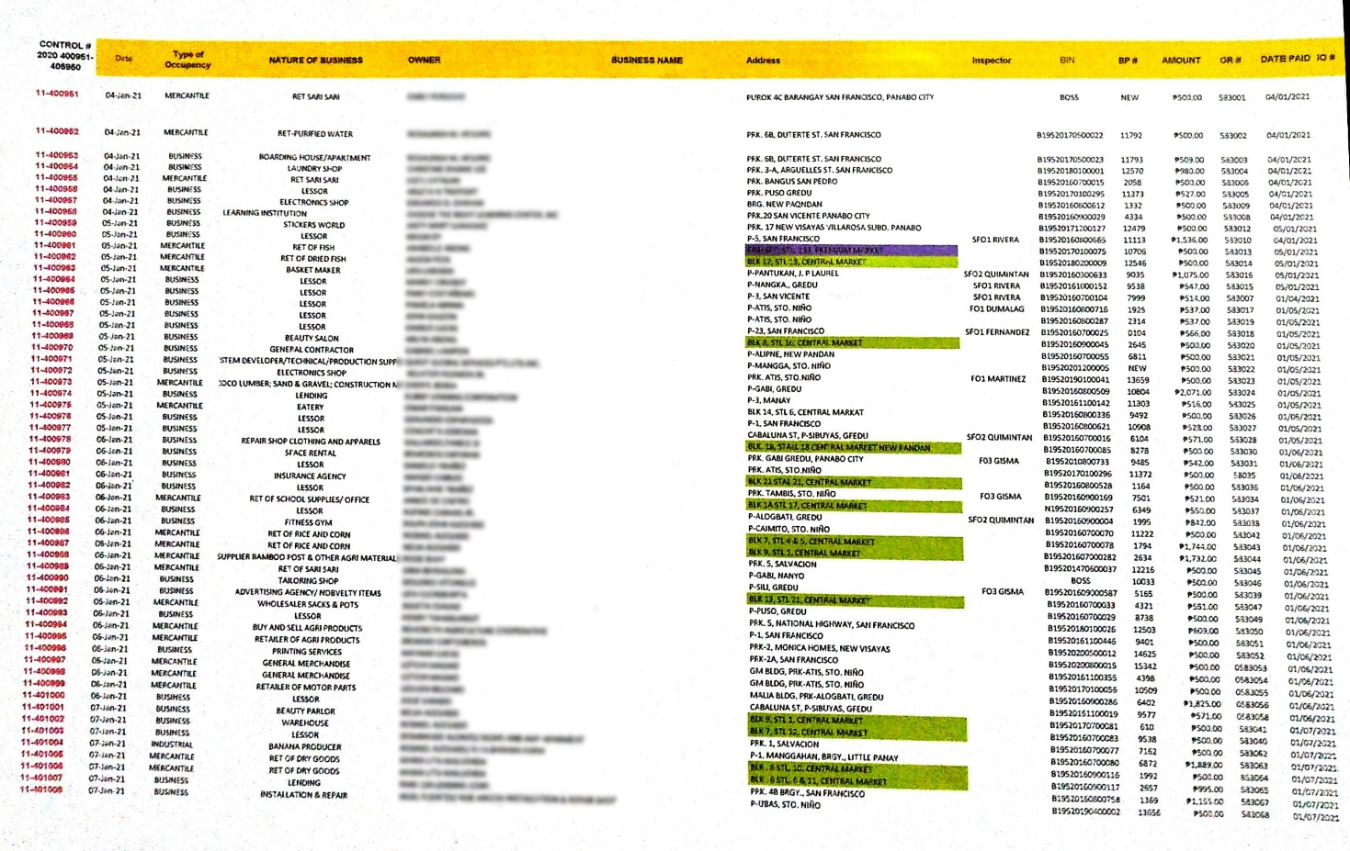

**GENERAL OBJECTIVE**

The researchers aims to develop Fire Safety Inspection Management System to further improve the current processes of the Fire Department that focuses in the area of Fire Safety.

**SPECIFIC OBJECTIVES**

Specifically, the capstone team plans a system that will be capable of doing the following:

Administrator:

* Provide a web-based application for the administrator for the major processes and management in Fire Safety specifically both process that are sent by the Fire Safety Inspectors and the Establishment Applicants.
* Allows the administrator to view, sort out, and monitor the status of the establishments that are in need for immediate renewal of documents in Fire Safety.
* Allows viewing of current geographical location of certain establishments. (Administrator – Web Application)
* Allows the archival of recently terminated establishments.
* Allows the Administrator to notify the Applicants for their approval whether they passed the inspection or not.
* Generate monthly and annual reports like how many business and establishment are applying in that certain span of time.
* Compute and receive fees and fines
  + Certificate fees, inspection fee, violation fee, etc.
* Generate certificate (Fire Safety Inspection and Fire Safety Evaluation Clearance)

Inspector:

* Provide a mobile application for the Fire Safety inspectors to record and send a file report back to the Fire Safety Administrator.
* Allows inspector to send information to the administrator whether the application is approved or rejected.
* Allows to record the applicant’s data from the inspection
* Allows to make note and feedback to the applicant’s establishment including the recommendations and defects.
* Allows the release of recommendation of re-inspection for compliance of requirements.

Applicant:

* Provide a mobile application for the applicants for the compliance of the requirements like Fire Safety clearance and certificates.
* Allow the applicant to send the requirements and prerequisite forms for fire safety application.
* Allows the payment of fees (certificate fee, inspection fee, violation fee, etc.)
* Receive notification prior to fire safety inspection whether they passed the evaluation or failed and be recommended for re-inspection.
* Allows applicant to receive and view the requirements to comply in re-inspection.

**SIGNIFICANCE OF THE PROJECT**

This project will redound to the benefit of the Panabo City’s Fire Department considering the fact that there are certain areas in the said establishment that needs improvement. Also for the fire safety inspectors and the applicants, this will ease up the effort from the paper works to a paperless approach.

**SCOPE AND LIMITATION**

* This project will be limited to Panabo City’s Fire Department in the Fire Safety Inspection Area.
* The system aims to provide web-based process for the Administrator and mobile-based for the Fire Safety Inspector and the Applicants.
* The Applicants are only limited to people of Panabo City who will apply for Fire Safety Certification
* The establishment should be currently placed at Panabo City.

This system has features such as:

Mobile Application (Applicant)

* In-app notification.
* Double log-in notification.
* Maximum of 3 Login Attempts and with a 30 seconds Timeout.
* SMS verification for the Two-Factor Authentication security.
* Emergency Alert

Mobile Application (Inspector)

* In-app notification.
* Double log-in notification.
* Maximum of 3 Login Attempts and with a 30 seconds Timeout.
* SMS verification for the Two-Factor Authentication security.

Web-based Application (Administrator)

* Log History
* Notify applicants if their application has been successfully approved or recommended for re-inspection.
* Double log-in notification
* Alert System
* Map service
* GPS
* Analyzes how many establishment has successfully acquired Fire Safety Inspection Certificate in that particular span of time.
* Can predict if the applicant is recommended to re-inspection
  + The re-inspection prediction in data mining feature here shall determine based on how many violations and deficiencies from the necessary requirements the establishment has.